Indraprastha Institute of Information Technology Delhi (IIITD)
Department of Computational Biotechnology

BIO213 – Introduction to Quantitative Biology

MID-SEM EXAM (September 28, 2025)
______________________________________________________________

Time duration: 1 hour Total marks: 50

SECTION I
Multiple choice questions. (1 mark each)
Question 1. In BLAST, the E-value indicates:
- The probability of the query being an exact match
- The expected number of random hits of a given score
- The evolutionary distance between two sequences
- The percentage of identical residues

Question 2. Which of the following errors occurs when two fragments from different regions of DNA join end-to-end?
- Contamination
- Base call error
- Chimera
- Deletion

Question 3. Which statistical method evaluates the reliability of a phylogenetic tree by resampling with replacement?
- Jackknifing
- Bootstrapping
- UPGMA
- Maximum Parsimony

Question 4. Which one is true for a Eulerian Walk in De Bruijn graph assembly?
- It visits every vertex exactly once
- It visits every edge exactly once
- It minimizes sequence length
- It removes repeats automatically’

Question 5. You are aligning two proteins where only the central domain is conserved, but both sequences have long, unrelated N- and C-terminal tails. Which alignment method prevents those tails from dragging down the score?
- Global
- Local
- End-free
- Multiple sequence alignment

Question 6. You observe a dot-plot diagonal that shifts slightly downwards midway, as if “broken.” What does this pattern suggest?
- An inversion
- Complete unrelatedness
- A small insertion/deletion event
- Two independent alignments

Question 7. In the MULTICONTIG model, what is a "weakest link"?
- The fragment with the most errors.
- The smallest link in a layout, defined by the number of overlapping positions.
- The longest fragment in a set.
- A fragment that does not overlap with any other fragment.

Question 8. Consider the following multiple sequence alignment layout

- KK ii.
KH
KR
KH
KR
KR
HK
KH
RK
HR
NK
KA

Which of the above (i or ii) is more likely to have a higher log-odd ratio for the event KR?

Question 9. Off-springs in Genetic algorithm are generated using
- Mutations and crossover
- Natural selection and crossover
- Natural selection and mutations

Question 10. Which of the following is an example of transition and transversion respectively?
- A C and A T
- C T and G A
- G C and C T
- A G and G T

SECTION II

Answer the following questions (do any 4) (5 marks each)

Question 11. In the RECONSTRUCTION model for fragment assembly, if ε = 0.3, is the placement of fragment GTCCA valid if its edit distance to the consensus sequence is 2?
Ans. RECONSTRUCTION Model:
ε= 0.3, Fragment = GTCCA (Length = 5), Edit distance = 2
Valid placement if edit_distance ≤ εx fragment_length
- 0.3 x 5 = 1.5
- 2 > 1.5 => not valid
Question 12. (a) Why is Neighbor Joining (NJ) often preferred over Unweighted Pair Group Method with Arithmetic Mean (UPGMA) for phylogenetic trees over UPGMA?
(b) In NJ, if d (A, B) = 4 and r(A)+r(B) = 12, N=4, what is M(AB)?

Ans. (a)
- UPGMA assumes a molecular clock (constant rate): Yields ultrametric trees; if evolutionary rates differ among lineages, UPGMA gives the wrong topology.
- Neighbour Joining (NJ) does not assume equal rates and often recovers correct unrooted topologies with unequal rates; it is fast and aims to minimize total branch length. Therefore, NJ is generally performed when rate constancy cannot be assumed.
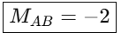
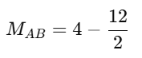
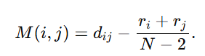
(b)
Compute,

Question 13. A researcher is sequencing a bacterial genome of size 3 Mbp. They want to achieve a minimum of 12x coverage using reads of length 150 bp.
(a) How many bases of sequence data are required in total?
(b) How many reads of length 150 bp must be generated to reach the target coverage?

Ans. Genome size = 3 Mbp = 3 × 10⁶ bp
Coverage 12 times
Read Length = 150 bp
- Total bases required = genome_size × coverage = 3,000,000 × 12 = 36,000,000 bases.
- Number of reads = total_bases / read_length = 36,000,000 / 150 = 240,000 reads.

Question 14. In the tree shown below, assume that the ancestor was an herb (not a tree) without leaves or seeds. Based on the tree and assuming that all evolutionary changes in these traits are shown, which of the tips has a tree habit and lacks true leaves?
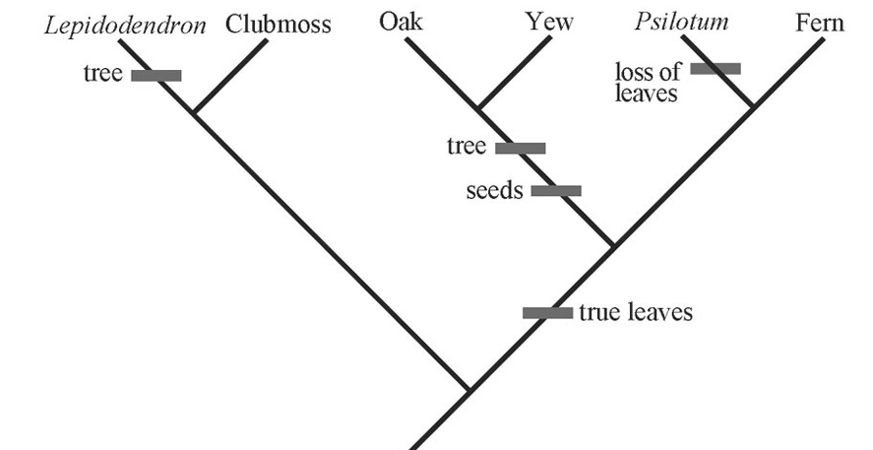
- Lepidodendron
- Clubmoss
- Oak
- Psilotum
- Fern

Question 15. Construct an overlap graph for F= (CTGA, GACT, TGAC, ACTG) with 3-mer overlaps, and derive the shortest common superstring.
3
Ans. ACTG CTGA

3
3

GACT TGAC
3

For shorter common superstring: ACTG
CTGA
TGAC
GACT
ACTGACT

SECTION III

Long answer questions (do any 2) (10 marks each)
Question 16. Find the local regions of similarity between the following DNA sequences using dynamic programming and the given scoring scheme.
DNA sequences: (1) TGTTACGG and (2) GGTTGACTA
Scoring function: Match = +3, Mismatch = -3, Gap = -2.

Ans.

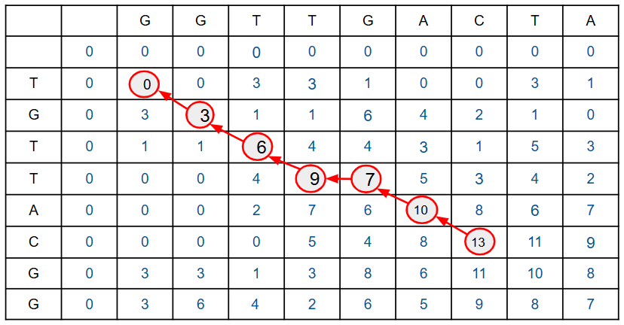

GTT_ AC
GTTGAC

Question 17. A researcher is working with the following sequences of flagellin proteins from five different bacteria of similar lineage to find the phylogenetic relationship between.

 | 1 | 2 | 3 | 4 | 5 | 6 | 7 | 8 | 9
Seq 1 | A | T | T | T | A | A | T | A | C
Seq 2 | A | T | G | T | C | A | T | A | A
Seq 3 | G | A | A | G | A | A | T | A | T
Seq 4 | G | C | G | A | G | A | C | C | C
Seq 5 | G | C | G | T | C | A | A | T | G

(i) Identify the parsimony informative sites from the given alignment layout?
(ii) Using the informative sites, determine the minimum number of mutations required for each of the following unrooted trees?
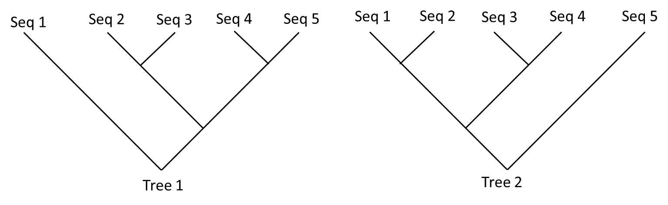
(iii) Which tree is favorable by maximum parsimony principle?

Ans. (i) 1, 2, 5
(ii)
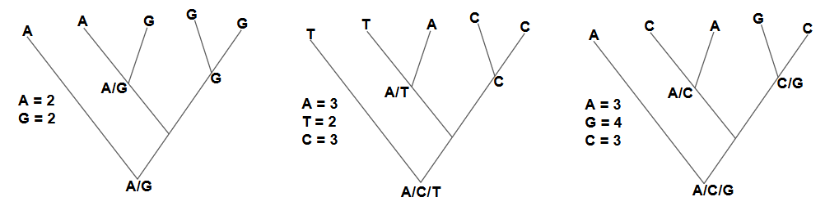

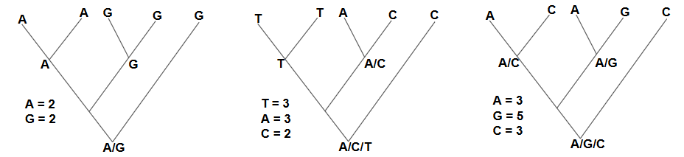

 | Site 1 | Site 2 | Site 5 | Total Changes
Tree 1 | 2 | 2 | 3 | 7
Tree 2 | 1 | 2 | 3 | 6

(iii) Tree 2 is favourable.

Question 18. Given a set of reads comprising of ATGC, GCGT, TGCG and CGTA,
(a) List all k-mers of length 3 from these reads.
(b) Construct the De Bruijn graph with (k–1)-mers as nodes.
(c) Find a Eulerian path that reconstructs the genome.

Ans. (a) List all K-mers (K=3) from reads

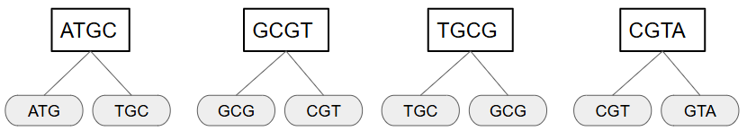

Unique 2-mers: ATG, TGC, GCG, CGT, GTA

(b) De-Bruijn graph (K-1) = 2 mer nodes

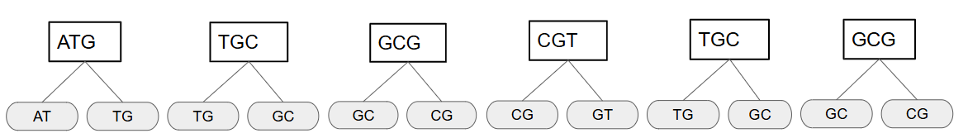

Reconstructed sequence – ATGCGTA (length = 7)

